**How to Deploy a Spring Boot - Spring Batch application on OpenShift**

**Prerequisites**

* Maven is configured in your system
* Docker should be installed in your PC

**Steps to create the Docker Image and Push it into DockerHub**

* clone or download source from: <https://github.com/samme4life/spring-batch-example>
* using command prompt go to the root of the application
* issue following commands,
  1. mvn clean package
  2. docker build -t spring-batch-example .
  3. docker tag spring-batch-example <hub_user>/<repo_name>:<tag>
  4. docker push <hub_user>/<repo_name>:<tag>

Now you’ll be able to see your docker image in the DockerHub

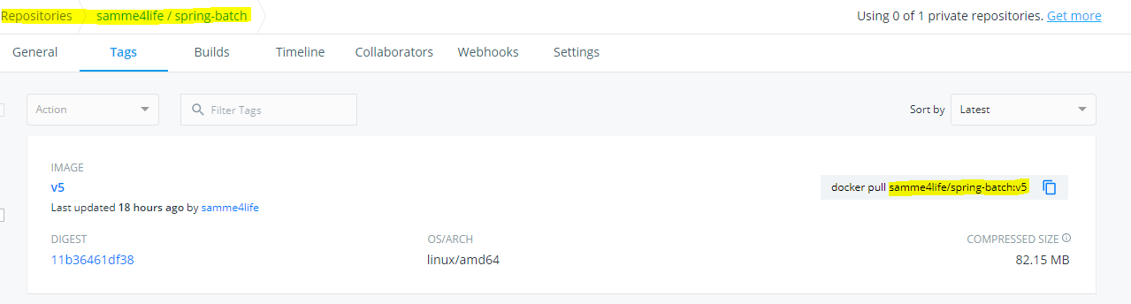

**Steps to Deploy a Docker Image from DockerHub**

* Go to your OpenShift Web Console and select the dedicated project

NOTE: You can create your OpenShift Online cluster from [here](https://www.openshift.com/products/online/)

* From the “**Add to Project**” drop down list in the top-right corner, select “**Deploy Image**”

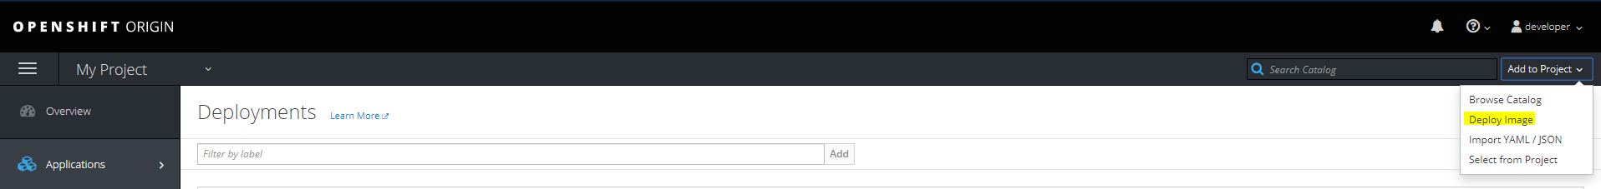

* Select the “Image Name” option and give **<hub_user>/<repo_name>:<tag>** as follows,

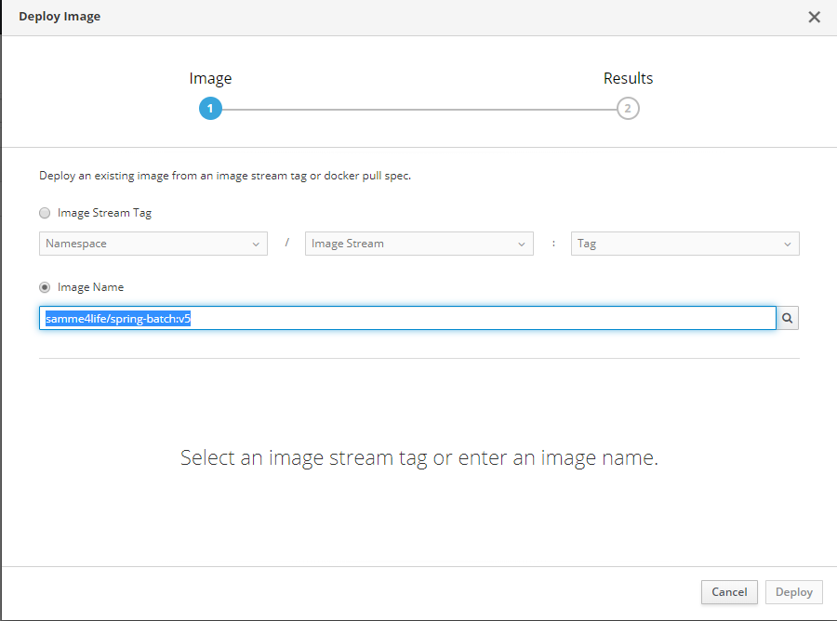

Click “Deploy”

* The app will be shown in the “Deployments” section as follows,

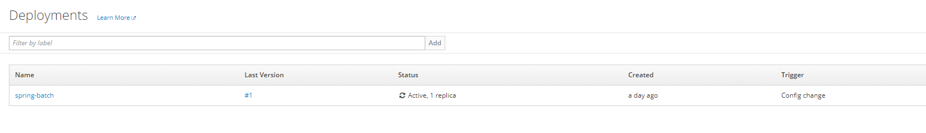

* Create a Route from the Service in order to expose the app to external world.

**REST API URLs**

* Status: <route_url>/health
* In Memory H2 DB: <route_url>/h2
* URL: <route_url>/h2

queries:

select * from USER;  
  
select * from BATCH_JOB_EXECUTION;  
select * from BATCH_JOB_EXECUTION_CONTEXT;  
  
select * from BATCH_STEP_EXECUTION;  
select * from BATCH_STEP_EXECUTION_CONTEXT;

* To call the SpringBatch job launcer: <route_rul>/load

**Reference**

* The instructions on this application found here: "<https://www.youtube.com/watch?v=1XEX-u12i0A&list=PLGVPYDuhQp5INh38gIrWWW9xeYrWuIYYB&index=3&t=2028s>"
* Related DockerHub Images can be found here: "<https://hub.docker.com/repository/docker/samme4life/spring-batch/general>"